**NC Beef Cattle Improvement Program 2024 Bull Test Summary**

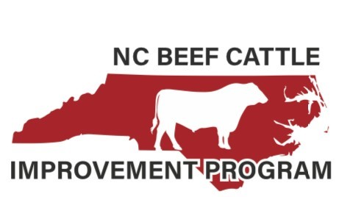Thirty-six bulls with an average weight of 845 pounds weighed on test in July at the Mountain Research Station. They were consigned by nine seedstock operations, which were all located in North Carolina. The breeds represented were Angus (30), SimAngus (1) and Polled Hereford (5). Bulls were developed on a corn silage based ration, ultra-sounded for carcass merit and given a breeding soundness exam. The final weight was taken on October 23 and bulls averaged 1,217 pounds across all breeds. Bull posted a 3.3 lb. ADG, which met the performance targets based on the ration formulation. A selection index using adjusted yearling weight ratio and ADG ratio was used to establish the sale order and to recognize the high indexing bulls within each breed. High Indexing Angus was Lot 10 consigned by Hawk’s Nest Farm, Leicester. High Indexing SimAngus was Lot 31 bred by Keziah Farms, Monroe and High Indexing Polled Hereford was Lot 40 raised by Four B Farms. To be eligible for the sale bulls must meet performance targets, be structurally sound, have a good disposition and pass a breeding soundness exam. The 45th Annual Waynesville Bull Test Sale was held on December 7 and 24 bulls were offered. The high selling bull was Lot 40 the Four B Farms consignment and was purchased by Warren Gillespie, Alexander, NC. The 24 bulls averaged $3,662.50 with gross sales of $87,900.

Forty-three bulls weighed on test at the Butner Beef Cattle Field Lab in Bahama, NC on July 15. They originated from seven North Carolina seedstock operations. The average starting weight was 875 pounds. Breeds represented were 42 Angus and one SimAngus and they were developed on a corn silage based ration. Carcass ultrasound measures and a breeding soundness exam were conducted. The test concluded with final test weights taken on November 4 and 1,292 pounds was the average off test weight. The bulls performed well with an impressive 3.8 pounds per day ADG. The index calculation revealed Lot 11 was the High Indexing Angus bull consigned by Panther Creek Farms, Pink Hill. The 41st Annual Butner Bull Test Sale was on December 20 at the Granville County Livestock Arena near Oxford. Twenty-one bulls sold for the average price of $5,147.61. The high selling bull was Lot 14 consigned by Panther Creek Farms and purchased by William Vernon, Milton, NC for $7,750. The Butner Sale grossed $108,100 on 21 bulls.

Thank you to the Mountain Research Station and Butner Beef Cattle Field Lab staff for taking excellent care of the bulls. We appreciate the opportunity to work with the consignors and buyers in this event. We look forward to seeing the new bull crop next year and we hope to see everyone at the 2025 NC BCIP Bull Test Sales. If you have questions about how to consign or buy performance tested bulls please contact Johnny Rogers, [jrroger3@ncsu.edu](mailto:jrroger3@ncsu.edu).